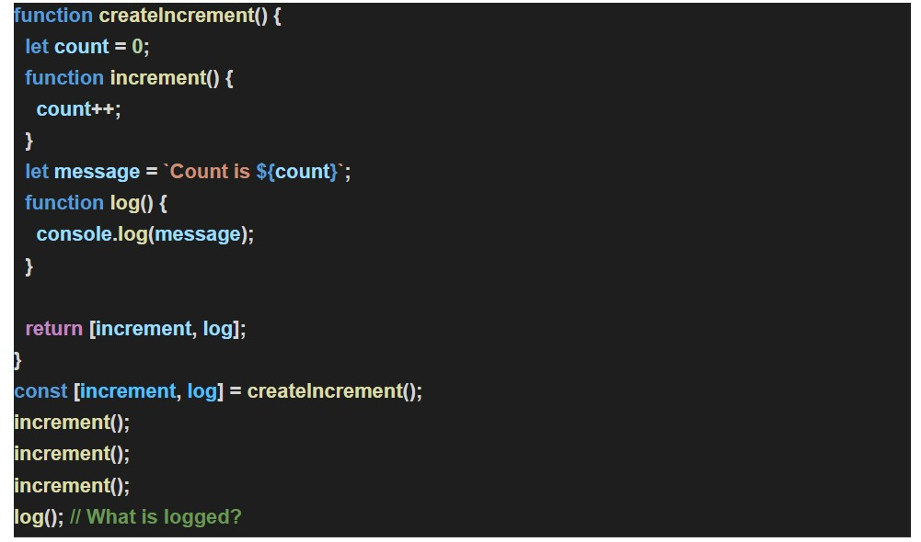

The O/P of the program is :
Count is 0
Reason for the Output :
During the execution of the program when this line is encountered
const[increment , log] = createIncrement();
what happens is that when this line is encountered the message string is created then here the message string is created as Count is 0
Later when ,
increment() - is encountered 3 times the count gets incremented by 1 every time but the thing to note here is that , when upon calling this function , it didn't alter the message string that was created earlier, so the message string remained as Count is 0 so when log(); was encountered finally, it printed the message Count is 0 as it was not altered by the 3 consecutive increments

